Whitewater Parks & Recreation

312 W Whitewater Street Whitewater, WI 53190 262-473-0122

[www.wwparks.org](http://www.wwparks.org/)

Exact Wording on the Banner:

(Alcohol, Tobacco products, Business Promotion, ineligible for inclusion on the banner)

Name of Group: Contact Person: Address:

Email Address:

Phone Number: Alternate:

Date Banner is to be put up:

Date Banner is to be taken down: Your Event Date:

Are you renting a City Banner? yes no

Preferred Banner Location: (Please state 1st choice & 2nd choice)

______ Birge Fountain on Main Street

______ UW-Whitewater Library on MainStreet

I have received and understand the required rental fees and policies relating to this request. I agree to follow stated policies and instructions given by this department.

Signature of Responsible Party: Date:

Rental Fee: $100.00 banner hanging 2nd week $50.00

$75.00 renting banner

**Office Use Only**

Amount Paid: Date Paid: Initials: Approved by:

Whitewater Parks & Recreation

312 W Whitewater Street Whitewater, WI 53190 262-473-0122

[www.wwparks.org](http://www.wwparks.org/)

**BANNER REQUEST FORM**

 The City has banners available to rent. These banners will be rented for 3-4 weeks: 2 weeks to paint, and 1-2 weeks to have the banner hung over Main Street.

 Banner requests are considered on a first-come-first serve basis. Payment must be made at the time of reservation. Banner fees are non-refundable.

 There is a $100.00 hanging fee for banners. There is an additional $75.00 fee if you need to rent one of the City banners.

 The renter is responsible for painting over the previous message (using white outdoor latex paint) and then painting their own message on the banner (using outdoor latex paint). Please be sure to paint both sides of the banner with your message. Be sure that the banner is orientated correctly so that the top is the same on both sides.

 Announcements painted on a banner must be of a general community concern and non-profit in nature. We will not hang banners with messages or sponsors involving: political campaigns, business promotion, tobacco and/or alcohol products.

 Banners can be picked up and dropped off at the City Garage, 150 E. Starin Rd. Please call (262) 473-0560to confirm pickup. The Garage is staffed Monday – Thursday 7am-3:00pm & Fridays 7am-9am. If you supply your own banner, please pick it up within 2 weeks after it was hanging on Main Street or it will be disposed of.

 A banner will hang for 7-14 days (from a Monday to Monday). Please have your banners to the City Garage no later than the Friday before they are scheduled to hang.

 There are two sites on Main Street for banners; Birge Fountain on Main Street or UW-Whitewater Library on Main Street. Requests for preferred hanging sites will be considered based on availability.

 Banner specifications are listed below.

* 25-28 feet of rope for each corner (4 corners total) of the banner.
* Eyelets/grommets are needed across the top of the banner

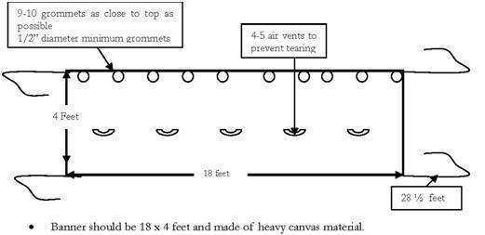

**Note:** To save on cost of banner creation, you have the option of the nylon rope not being sewn into the top and bottom; however, the banner should be sewn on all 4 sides for added durability.